PROMISE & PRACTICE · DEEP DIVE · SOURCE ANALYSIS
The Freedmen's Bureau — A House Divided
Success, Failure, or Both?
Name: ______________________________ Period: _____ Date: ________________
WHAT I CAN DO TODAY I can read primary sources about The Freedmen's Bureau — A House Divided, weigh who made each one and why, and use evidence to answer historical questions.
Directions. A fair judgment weighs both sides. Sort the evidence, then decide how to grade the Bureau

THE SOURCES
THE IMAGE · 1868 — “The Freedmen's Bureau”
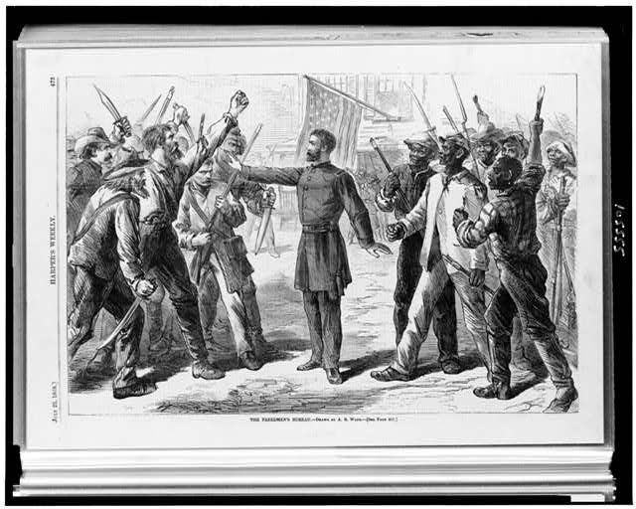
“The Freedmen's Bureau” — wood engraving by Alfred R. Waud, Harper's Weekly, 1868, public domain (Library of Congress).
SOURCE · THE BUREAU'S RECORD — Achievements and limits
Achievements: millions of food rations; ~4,000 schools; foundations of Black colleges; labor contracts enforced; families reunited; marriages legalized.
Limits: chronically underfunded and understaffed; fierce white resistance and violence; the promise of land mostly broken; shut down by 1872.
— summarized from the historical record. Public domain
— summarized from the historical record. Public domain.

YOUR WORK
QUESTION 1 STEP 1 · TWO COLUMNS
From the source, list two clear successes of the Freedmen's Bureau and two clear limits or failures.
____________________________________________________________________________________________
____________________________________________________________________________________________
____________________________________________________________________________________________
QUESTION 2 STEP 2 · THE BIGGEST FAILURE
Many historians call the failure to give freedpeople land the Bureau's most damaging shortcoming. Why would land have mattered so much?
☐ A. land was worthless after the war
☐ B. land meant independence; without it, freedpeople had to work for their former enslavers
☐ C. freedpeople did not want land
☐ D. land had nothing to do with freedom
QUESTION 3 STEP 3 · READ THE TEACHER
Using the teacher's quote, explain what the Bureau's schools meant to freedpeople. Why would families “starve themselves” to send children to school?
____________________________________________________________________________________________
____________________________________________________________________________________________
____________________________________________________________________________________________
QUESTION 4 STEP 4 · YOUR VERDICT
Given its impossible task and limited support, was the Freedmen's Bureau a success, a failure, or both? Defend your verdict in three or four sentences, using evidence.
____________________________________________________________________________________________
____________________________________________________________________________________________
____________________________________________________________________________________________
____________________________________________________________________________________________
____________________________________________________________________________________________
Promise & Practice · ShadowDog Digital Studios · Unit 2

TEACHER ANSWER KEY — The Freedmen's Bureau — A House Divided

QUESTION 1: Open response.
Look for a response along the lines of: “Successes: 1)… 2)… | Limits: 1)… 2)…”
QUESTION 2: Correct — B. land meant independence; without it, freedpeople had to work for their former enslavers
Right. Land meant economic independence. Without it, most freedpeople had to work for their former enslavers — which is exactly how sharecropping trapped them in poverty and dependence.
QUESTION 3: Open response.
Look for a response along the lines of: “Education meant… so families were willing to…”
QUESTION 4: Open response.
Look for a response along the lines of: “I would judge the Bureau as ___ because…”

